Subject : Create a Website using a Package program Code: ง40203
By Mrs.Thunsuta Na Lampang, Sobprabpittayakom School, Lampang provience.
*******************************************************************
Would you like to have a perfect website like this?
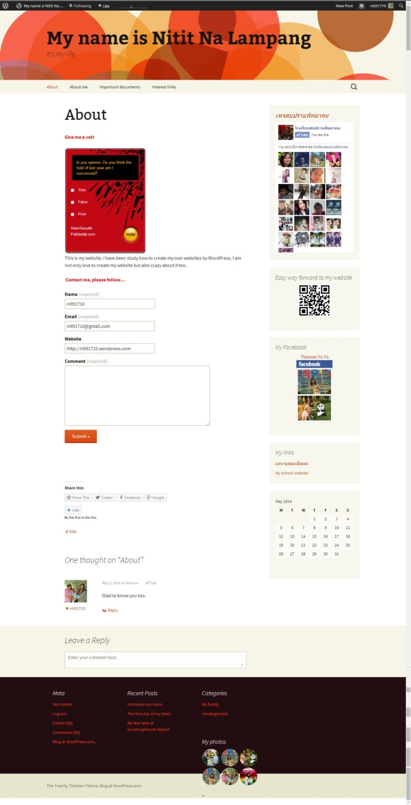
If you would, How should you do it?
WordPress is incredible website. It has many Widgets and accessories to embed in homepage.
For this lesson I will teach you follow this items.
- Add a poll
- Add a contact form
- Add a Facebook like box
- Embed a QR Code
- Add a Facebook profile
- Add Links
- Add a Calendar
- Add poll
Going to the “About” page then click the “Add poll” button to insert the poll on you website.
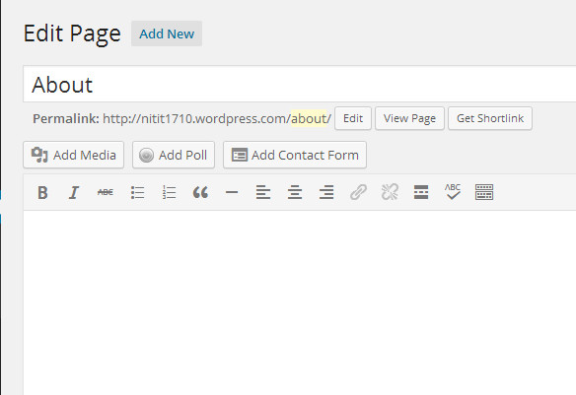
Click “Add new” if you would like to have another poll.
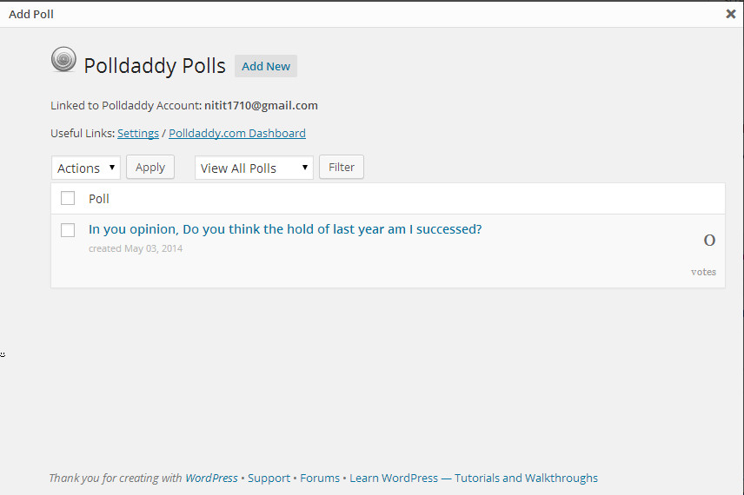
Type the question of the poll and the answers of this item.
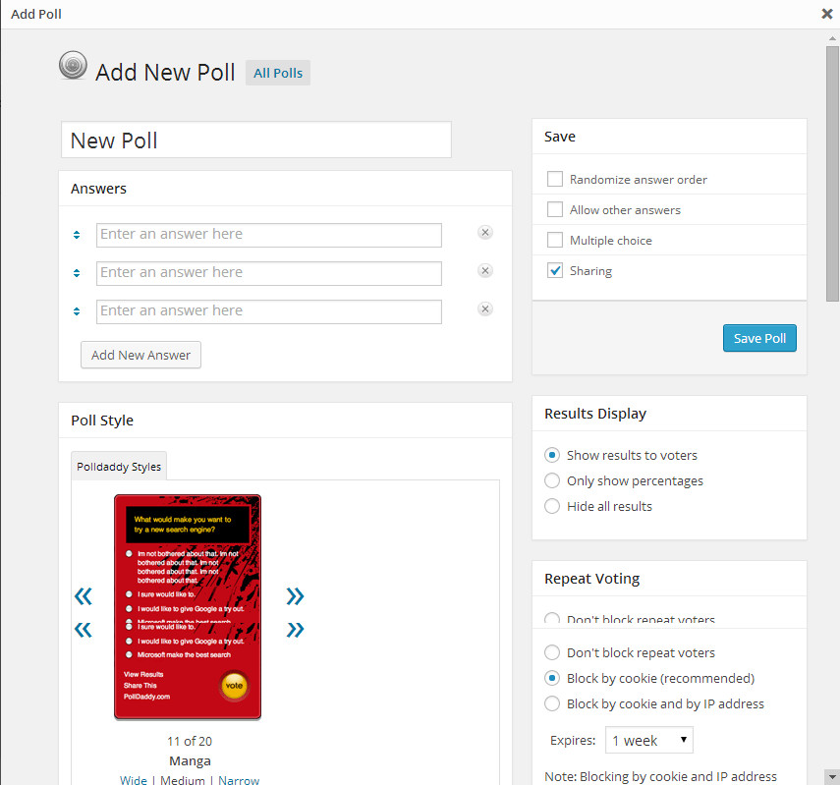
Select the poll style. It has 20 styles.
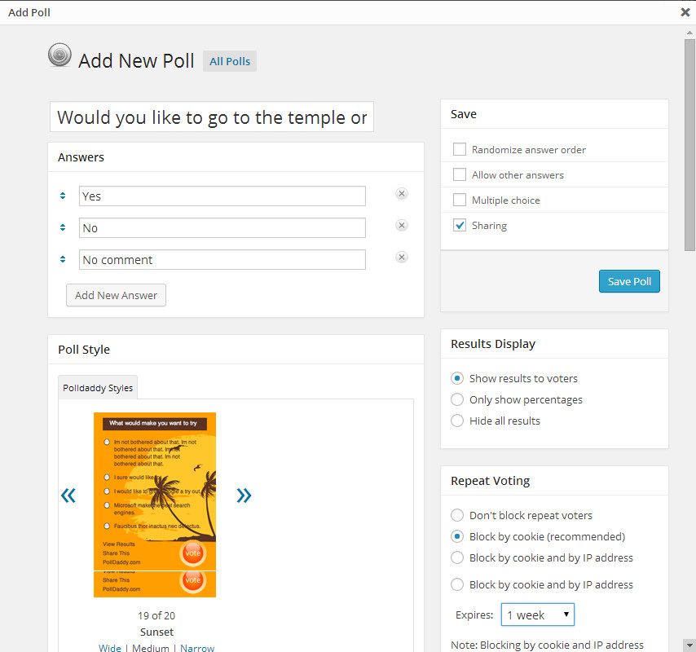
Choose one style then click the “Save Poll” button.

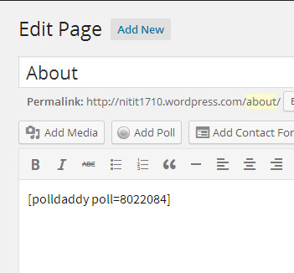
See the code of the poll in the edit area. Don’t forget to click “Update”
Go back to the homepage the poll will show on the “About” page.
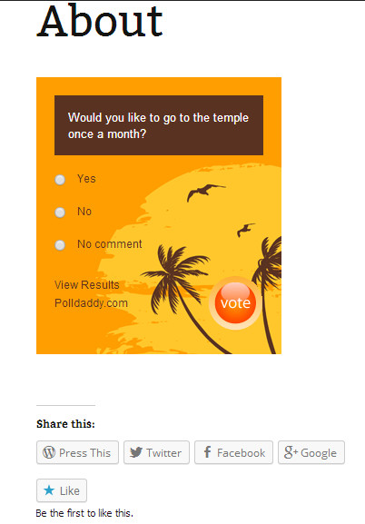
If you want to have more convenient contact from viewers to the webmaster. What should you do?
- Add a contact form
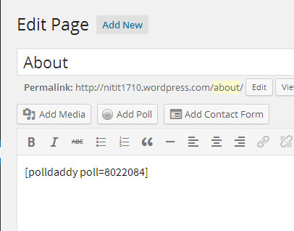
At “Add contact form” there are 2 pages. Here is what your form will look like? There are 4 fields necessary for each form. If you would like to add more fields you can click “Add a new field”. If you have enough fields please click “Add form to my post” .
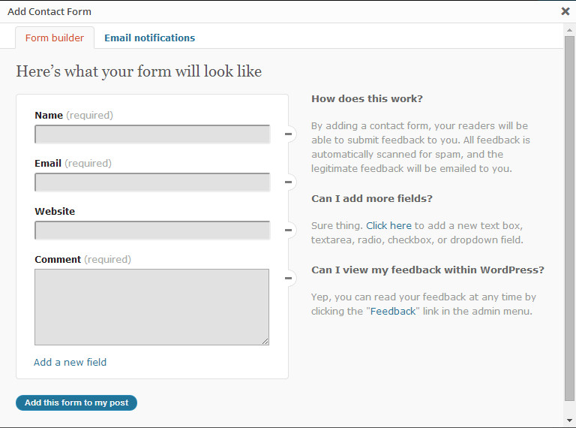
WordPress will show 3 lines of source code in the Editor area.
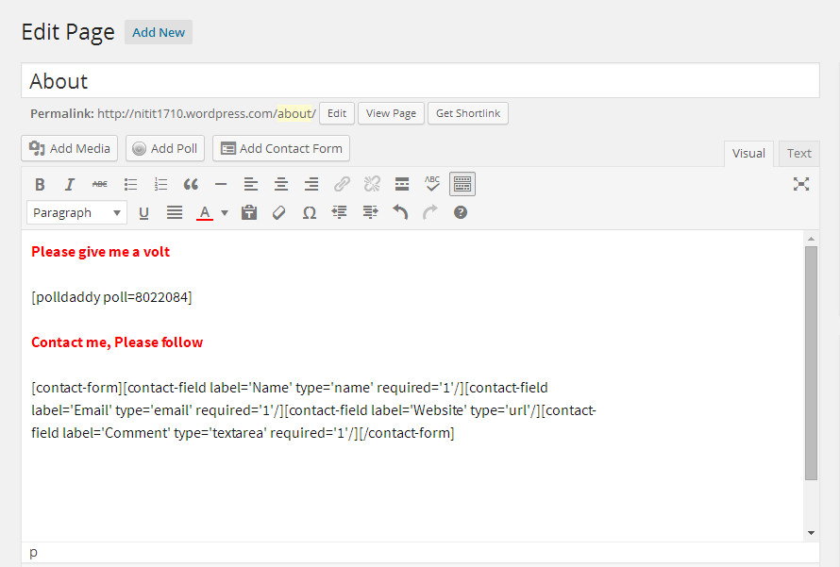
Go back to the “About” menu again. The contact form will appear like this.
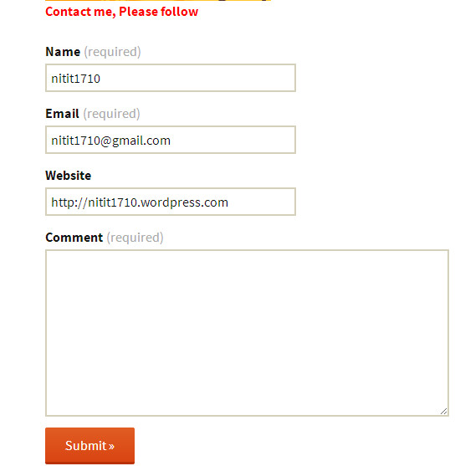
Try to fill in the field with your data and click “Submit”.
If you would like to see a Facebook like box from your Facebook to appear on your homepage, What should you do?
- Add a Facebook like box
Go to the Appearance menu at Dashboard.
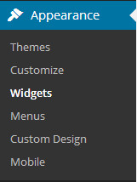
Click the “Widgets” submenu. On the right side will be you all of the Widgets. Scroll down to “Facebook Like Box”
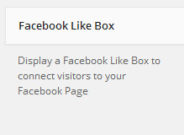
Click “Facebook Like Box” again to select to embed it into main the Widget Area or “Secondary Widget Area”. After you have finished please click “Add Widget” to connect visitors to your Facebook Page.
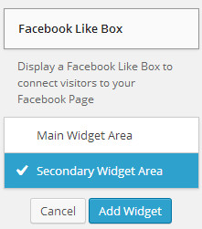
We can get your Facebook Page from your Facebook URL.
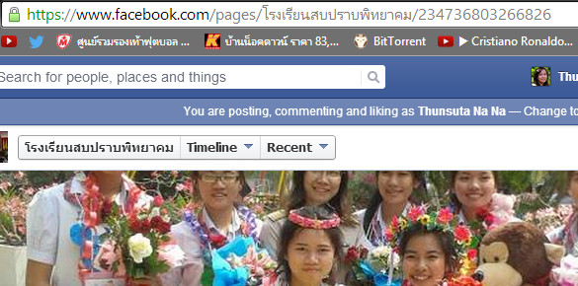
Please copy the Facebook URL to the “Facebook like box” at “Facebook page URL”.
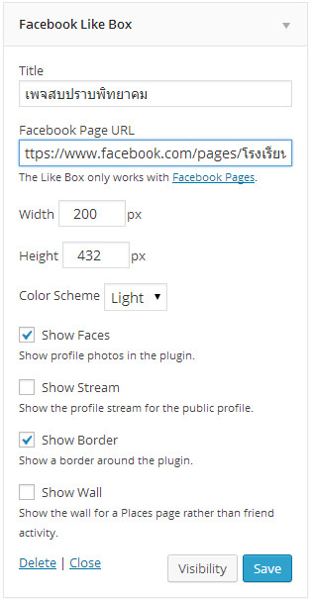
Don’t forget to fill the title then click “Save” when you are satisfied.
Go back to the “About” menu again then the “Facebook like box” should show on the screen on right side.
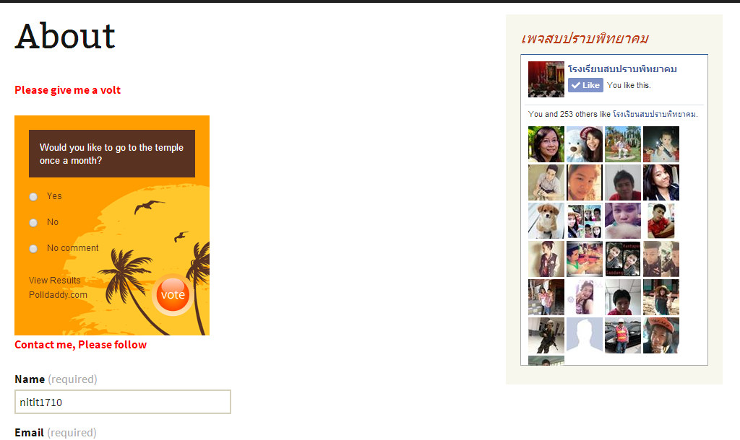
If you would like to show a QR Code, it is easy to Embed a QR Code on this page.

- Embed QR Code
Go to “qrcode.kaywa.com”. The homepage will show dialog to fill in the URL. Follow http://thai.sppit.ac.th
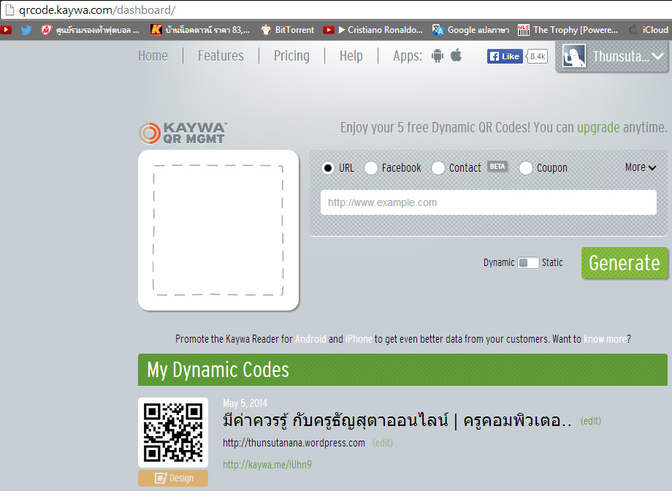

when you click “Generate” the qr code will be created. Look at “My Dynamic Codes”. In the bottom click “Embed” to show the qr code address then copy it.
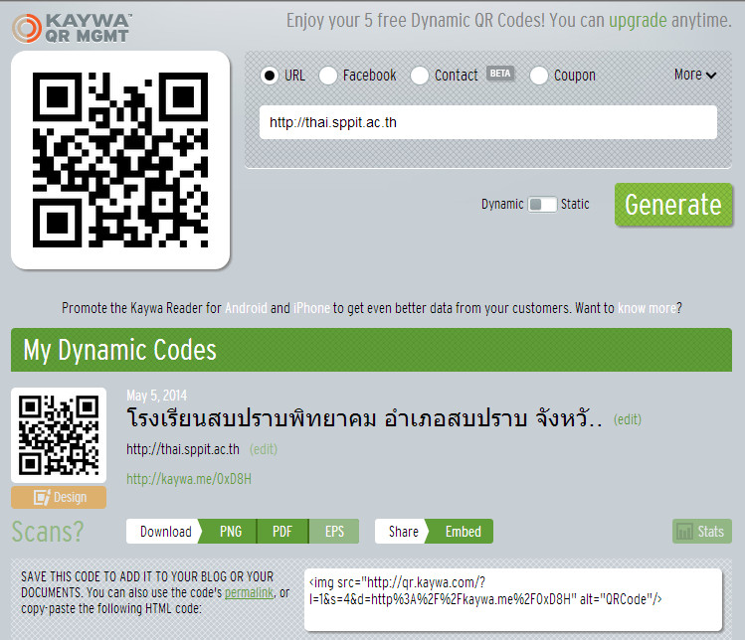
Go back to the “Text” widget, Click into the “Secondary Widget Area” then click the “Add Widget” button.
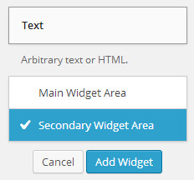
Paste the Qr code address into this area. Don’t forget to fill the Title name.
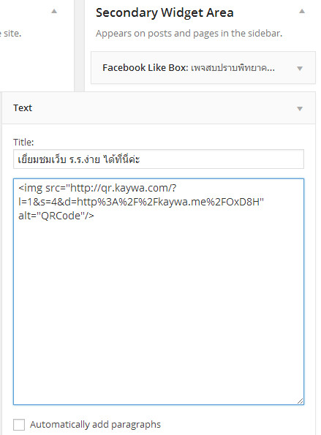
Click the “Save” button.
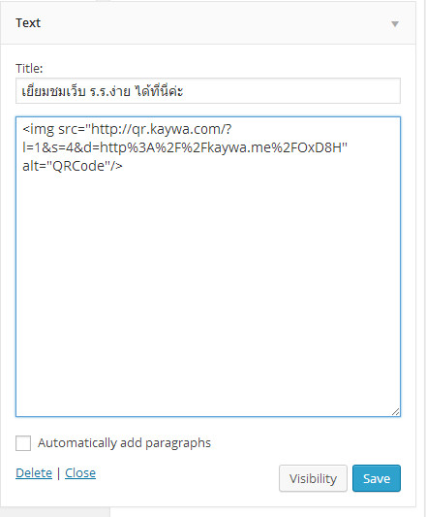
If you want to embed the qr code to show in the center, you must type <p align=”center”>……………</p> around the Qr code address.

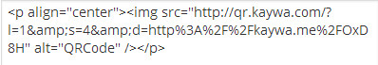

The qr code for the website URL that you provided will appear on the homepage like this.
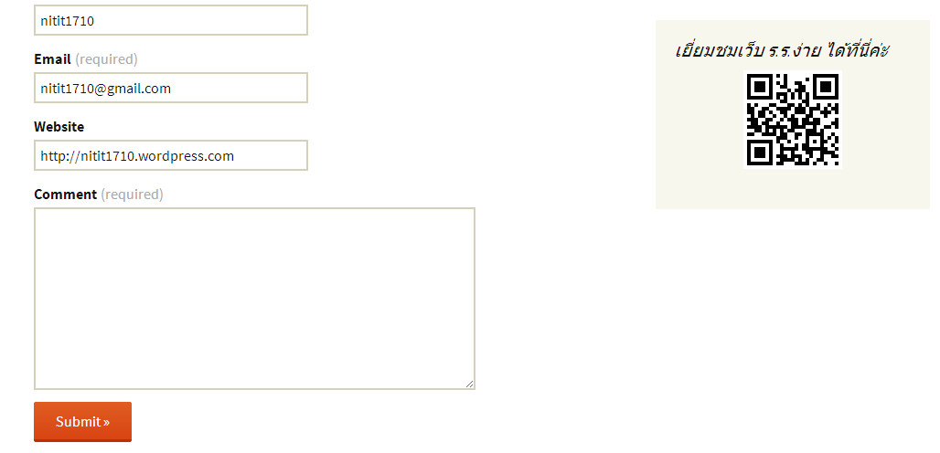
If you would like to show your Facebook embed on your website, You have to go to http://www.facebook.com/badges/profile.php on your Facebook profile.

5.Add Facebook profile
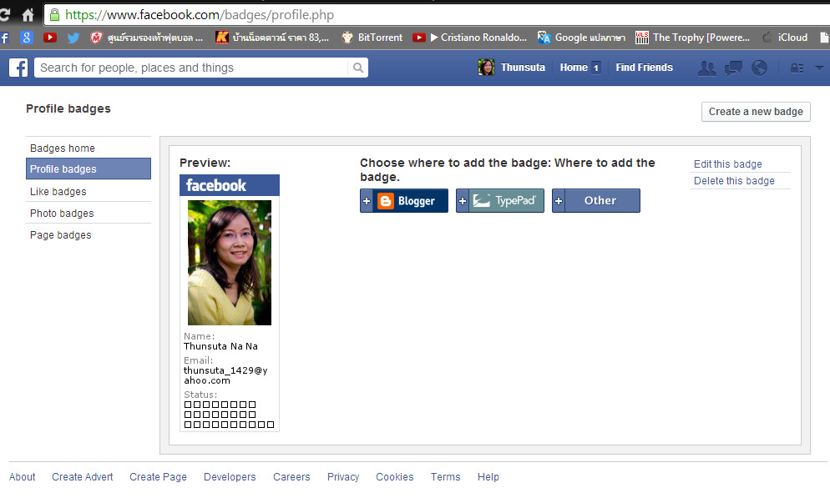
Choose where to add the badge. Click the “Other” button to get the code below. You can click “Edit this badge” to change the number of photos that show, then paste it on your website.
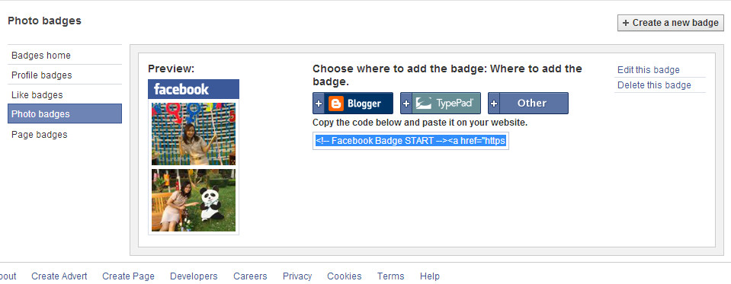
Go back to “Text” at widgets to check “Secondary Widget Area” then click “Add Widget”
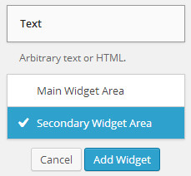
Paste code in the text area.
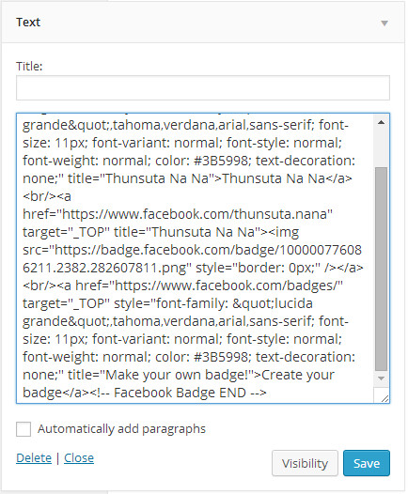
Don’t forget to click “Save” to embed it on your website. The Facebook profile will show like this.

- Links
It is easy to show links organized by category. Go to the Links widget and select “Secondary Widget Area” then click the “Add Widget” button.

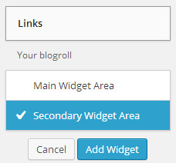

Select only one link to show.
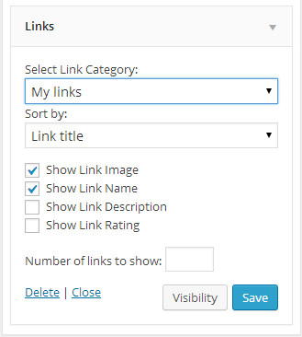
Click “Save”.
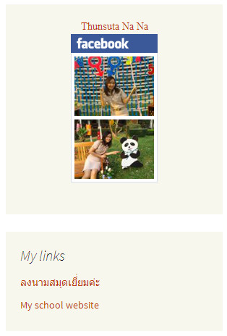
All of the pages in this link category show on the screen like this.

It is a Perfect website, isn’t it? If our website consists of a Calendar. What should you do?

- Calendar
Go to the Calendar menu in the Widget section. Click “Add Widget” in “Second Widget Area”.
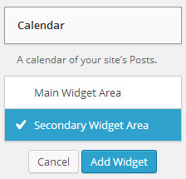
Fill in the box below with title and click “Save” . You can skip this step If don’t want to fill it in.
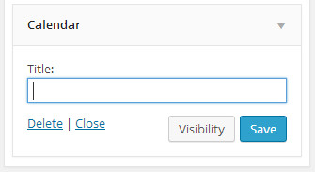
Go back to your homepage again. The Calendar will show on the screen. Is it more convenience for the viewer?
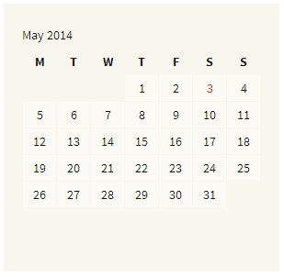
Keep on trying to add more widget in the “Main Widget Area” and the “Secondary Widget Area” if you would like to.
